

| Business Template  **DAX Basics** |
| --- |
|  |

## PART A: Creating Simple DAX Expressions

### 1.Calculated column

I began by adding a Year-Month Label column to the dim date table, using a **DAX FORMAT** function applied to the alternate date key to display the year and month name in the desired format.

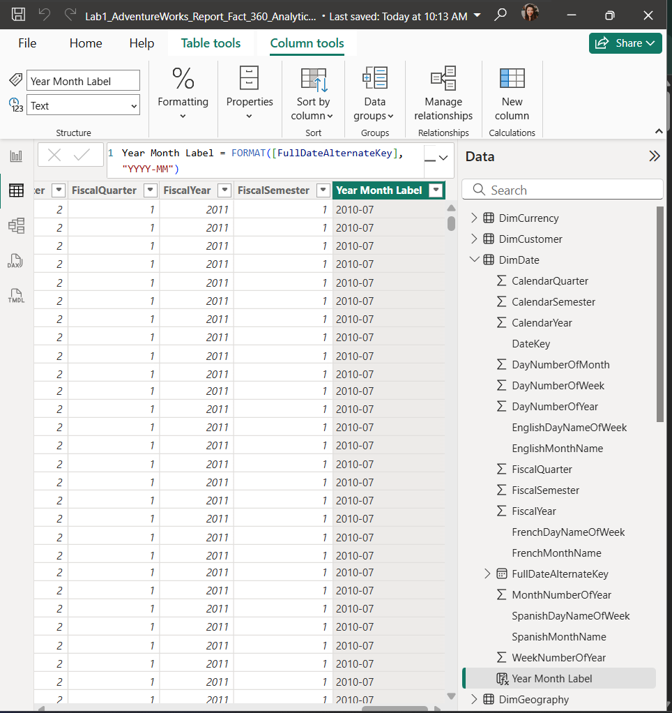

Next, I created a line graph showing the sales amount based on the Order Date from the Fact Internet Sales table, using the date hierarchy of Order Date on the x-axis. While this approach is useful for users who want to navigate through different hierarchy levels, it often results in some hierarchy elements being skipped or overlooked when switching between levels.

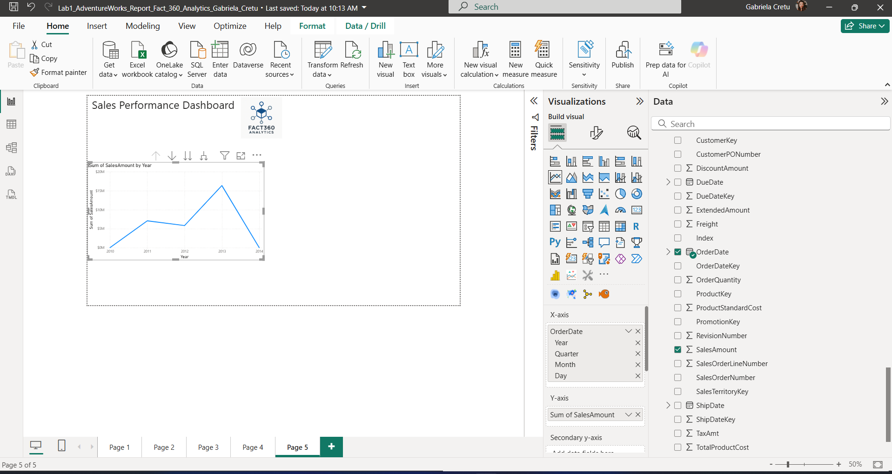

To display data by month, we used a line chart with the previously created Year-Month Label on the x-axis and sales amount on the y-axis. Additionally, we applied a filter on the year by adding the Year field from the dim date table to the visualization’s filters, setting it to include only years greater than or equal to 2013.

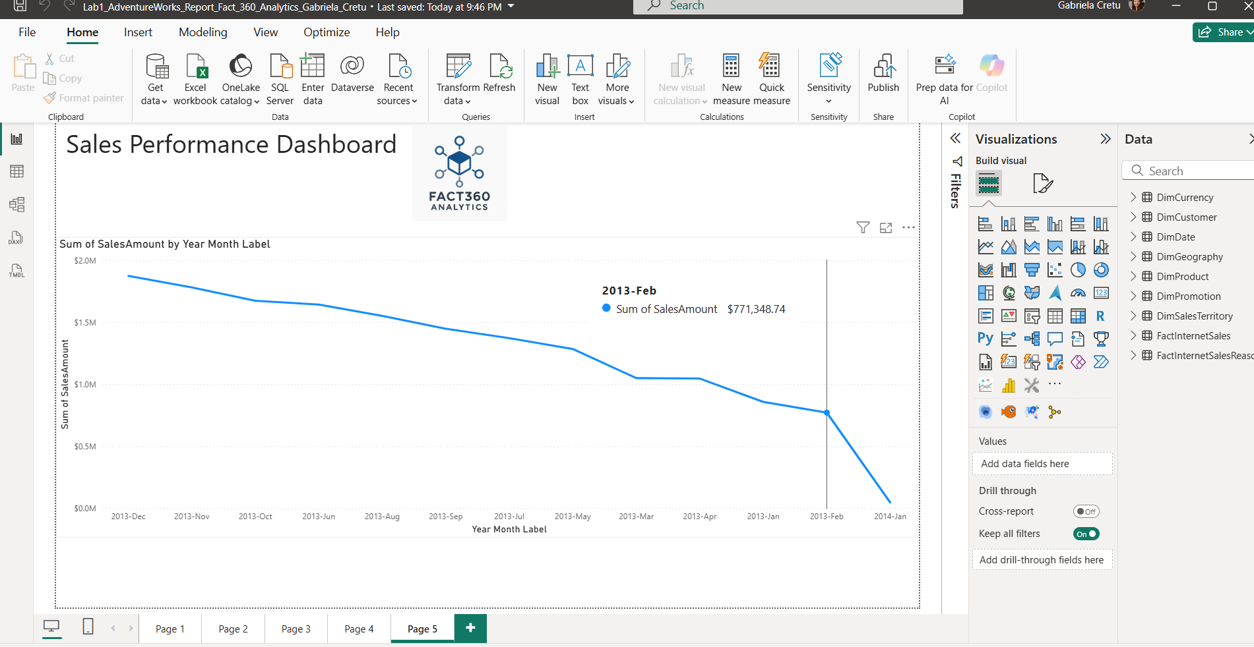

Next, we noticed that the data on the x-axis was not ordered in ascending order, making trend analysis over time ineffective. To fix this, we returned to the table view, selected the Year-Month Label column, and sorted it by the MonthYearKey. This ensured the dates are now displayed in ascending order.

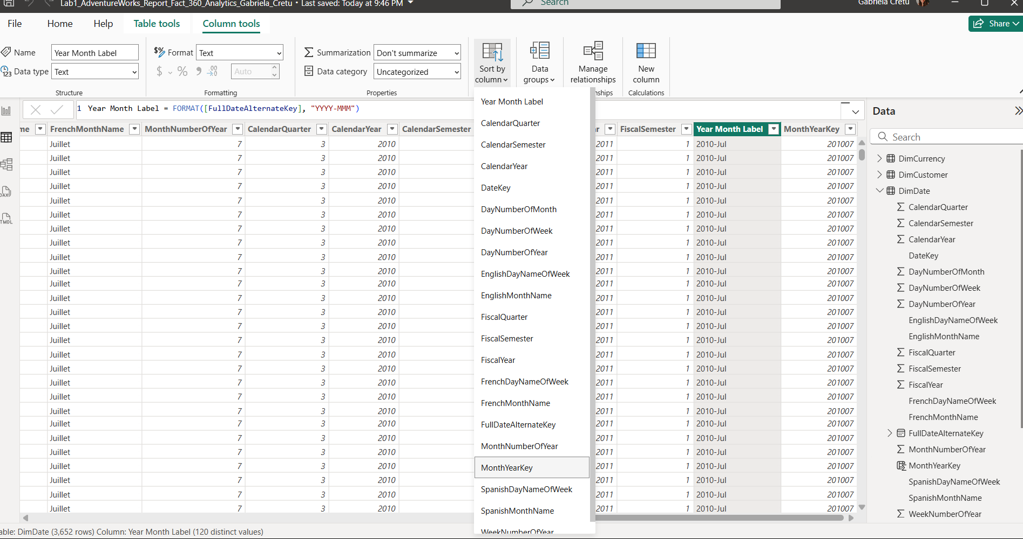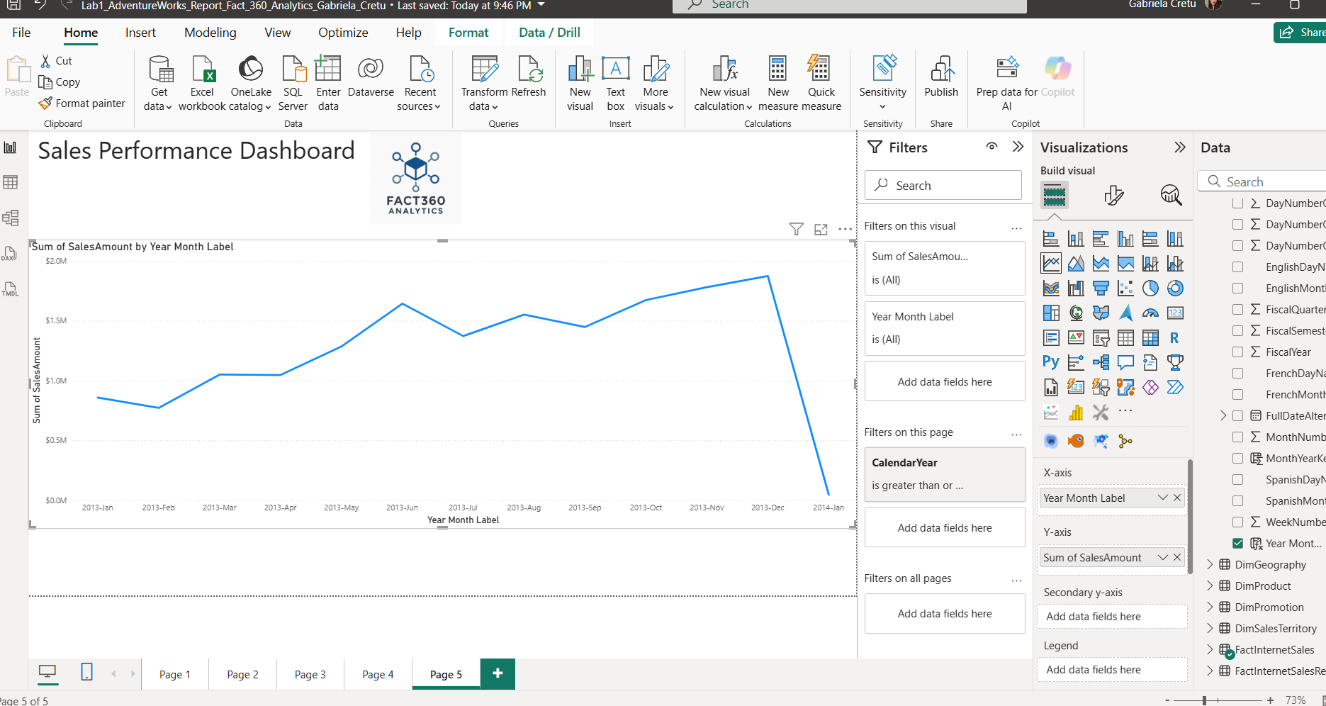

### 2.Measure

Now, let’s create a simple measure called Today Date using the formula TODAY(). You’ll notice that the measure is automatically created in the first available table if no other table is selected beforehand—in our case, it was added to the DimCurrency table.

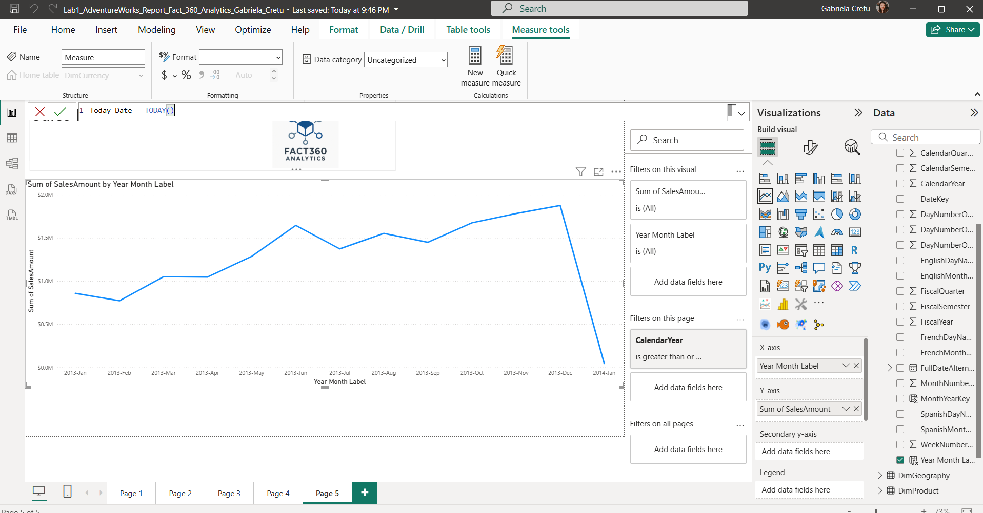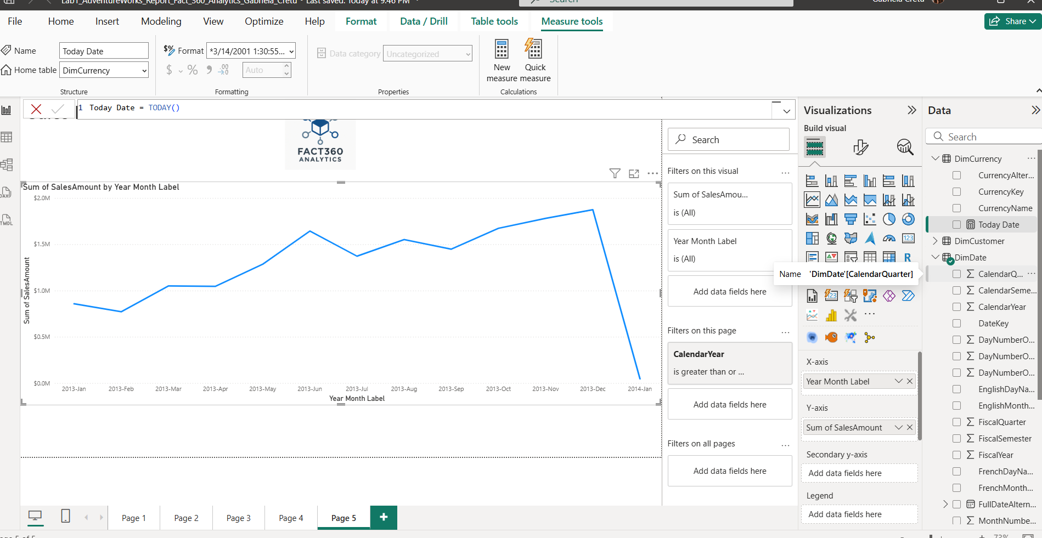

Next, we displayed the date in the report using a card visualization, which works well when showcasing a single value or just a couple of values. Since the default date format wasn’t very appealing, we navigated to the Measure Tools pane (which appears when creating or selecting a measure) and changed the format to Short Date, as shown in the screenshot.

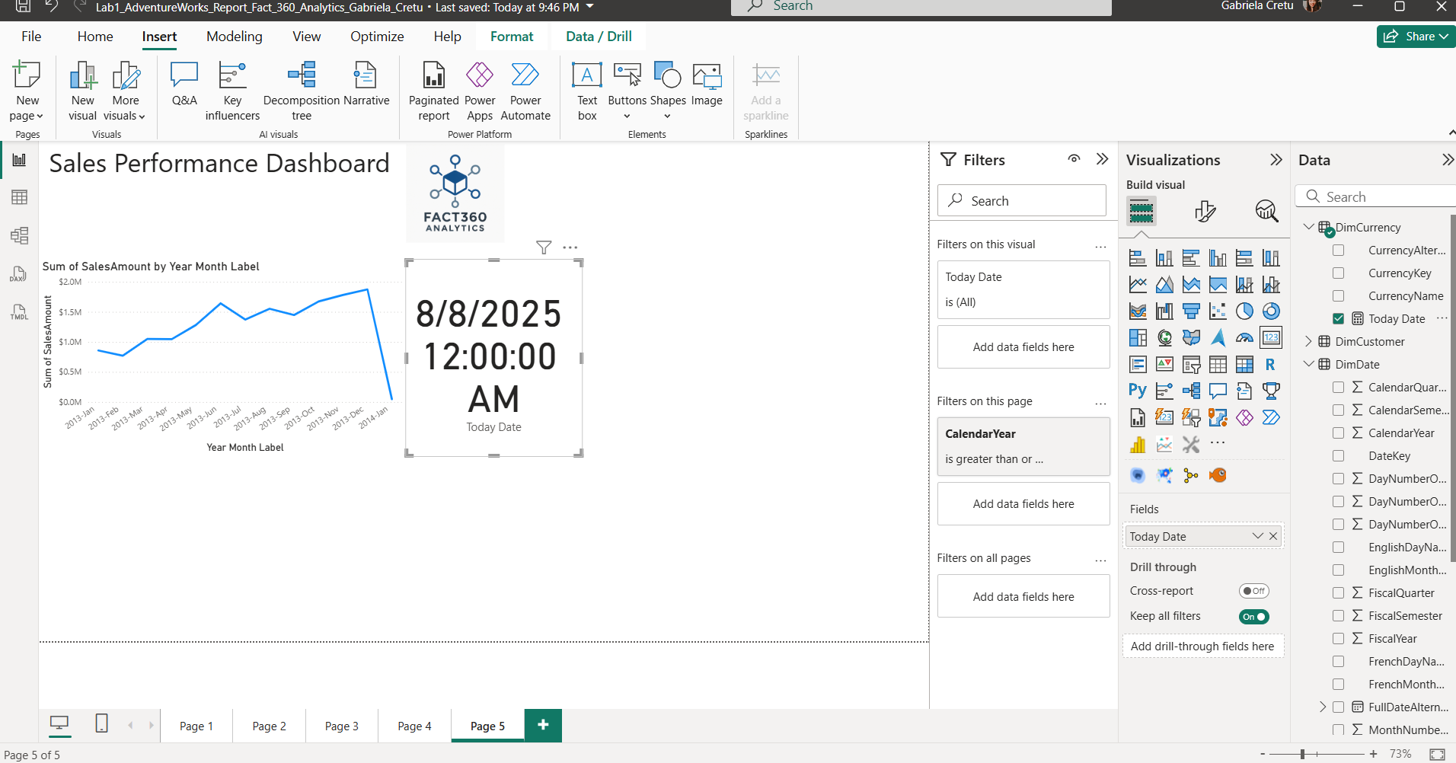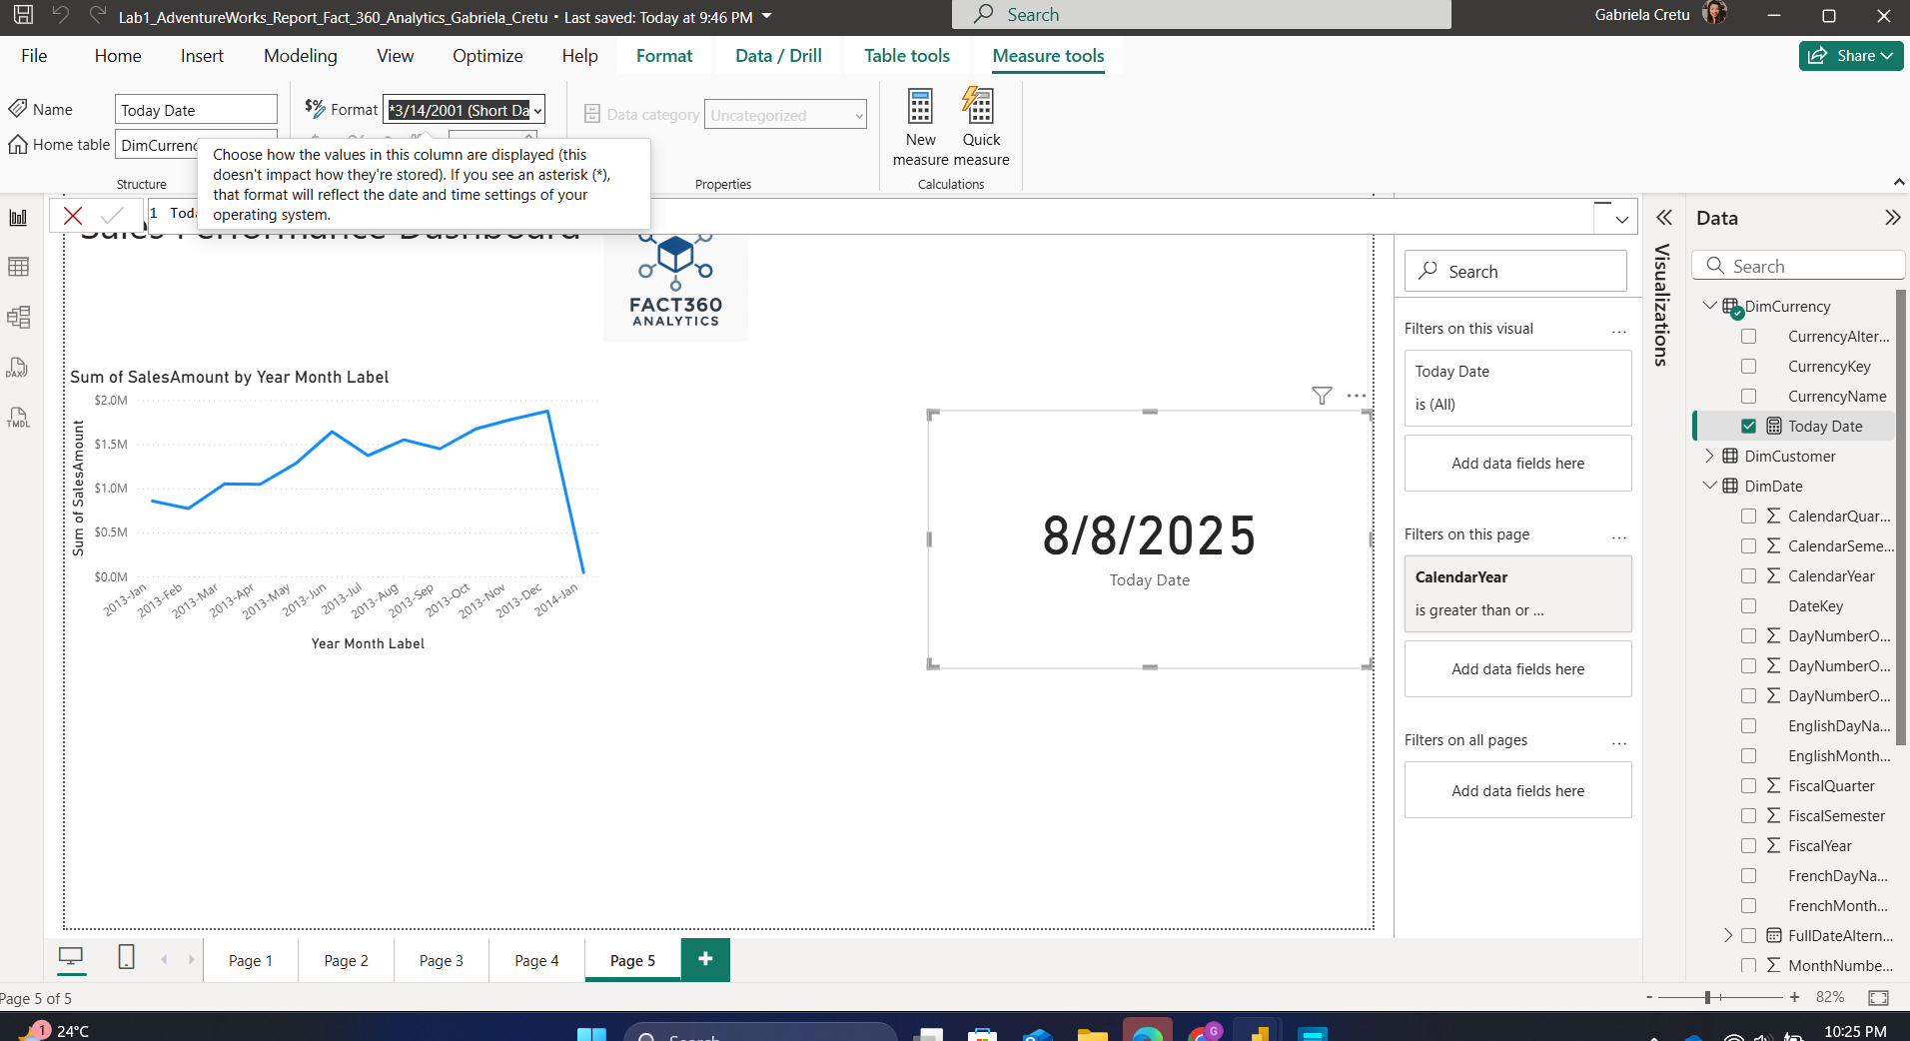

Next, we added the date as a footer in the report. We also used a control to select both the graph and the date, grouping them together as shown in the screenshot.

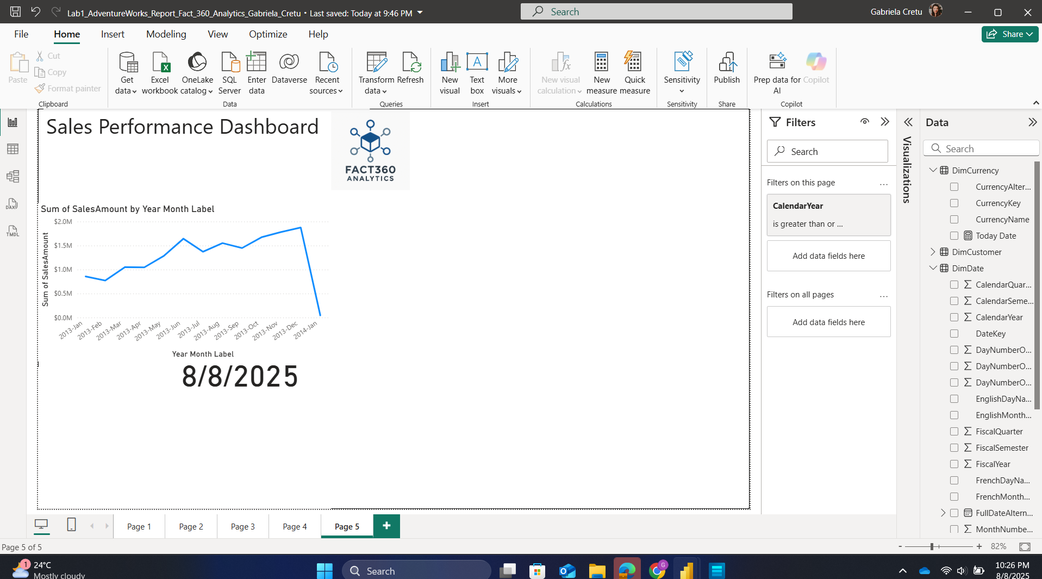

Now, moving beyond simple measures, we define a more complex one—an Order Quantity measure that calculates the total quantity of products in the FactInternetSales table using the SUM function.

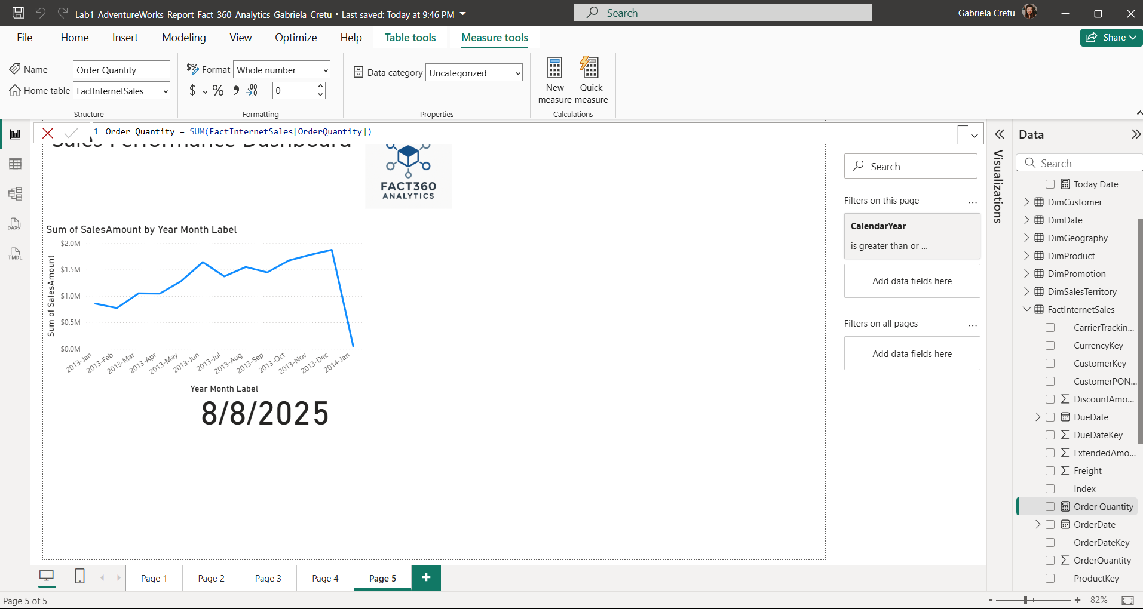

Next, we decided to add an additional Date field that is more readable in the report compared to the existing full date alternate key. To achieve this, we use a DAX approach where we extract the date components by applying modulo and division operations on the date key, which is essentially a numeric representation of the compacted date. The values are th

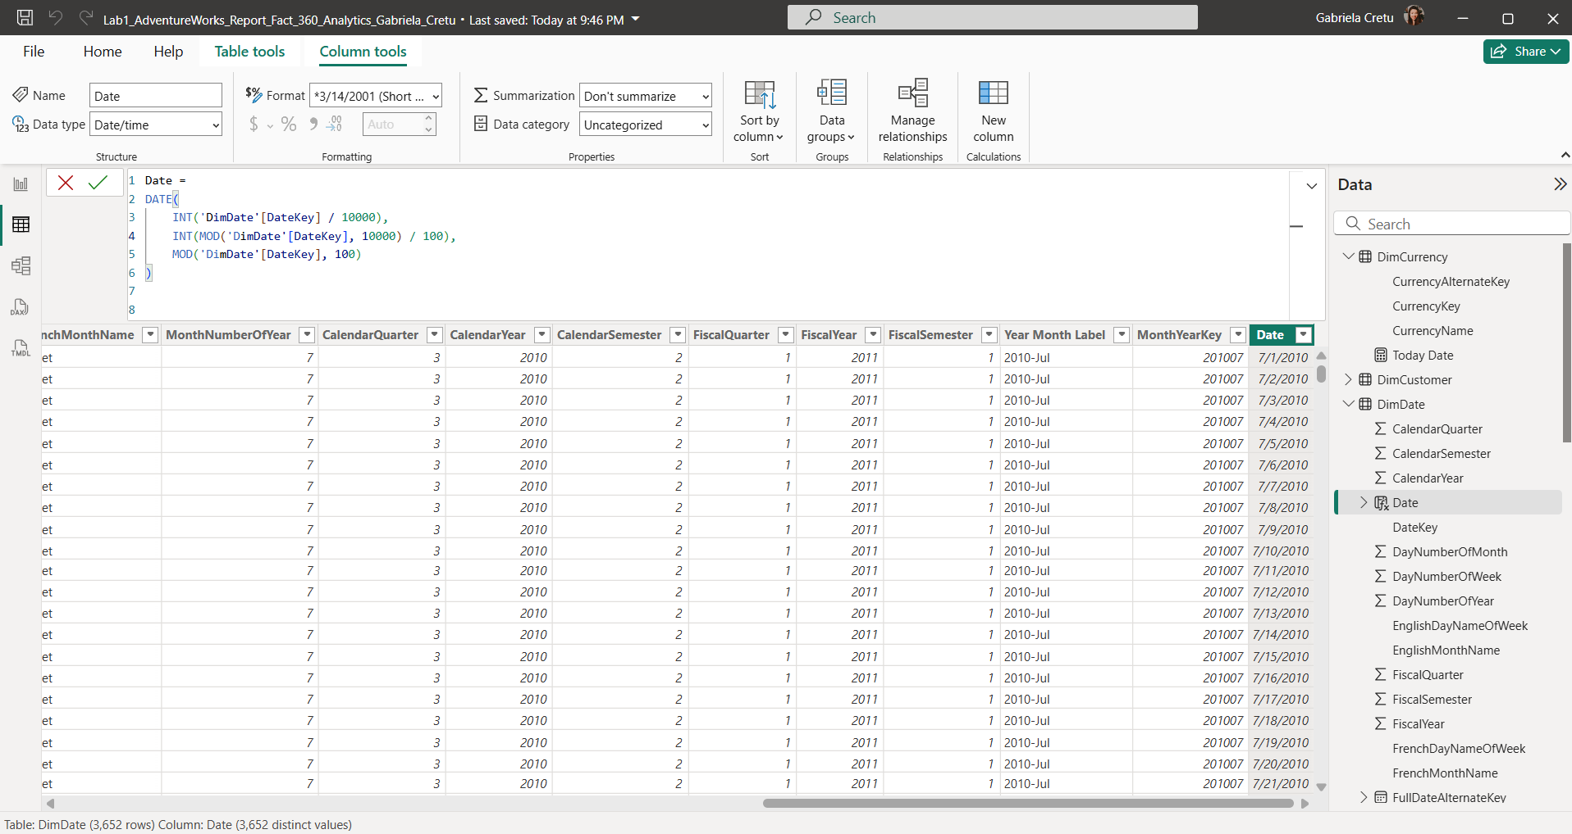

Next, we created a table visualization to display the order quantity—calculated using the previously defined measure—on a specific day, alongside the new date field we just defined.

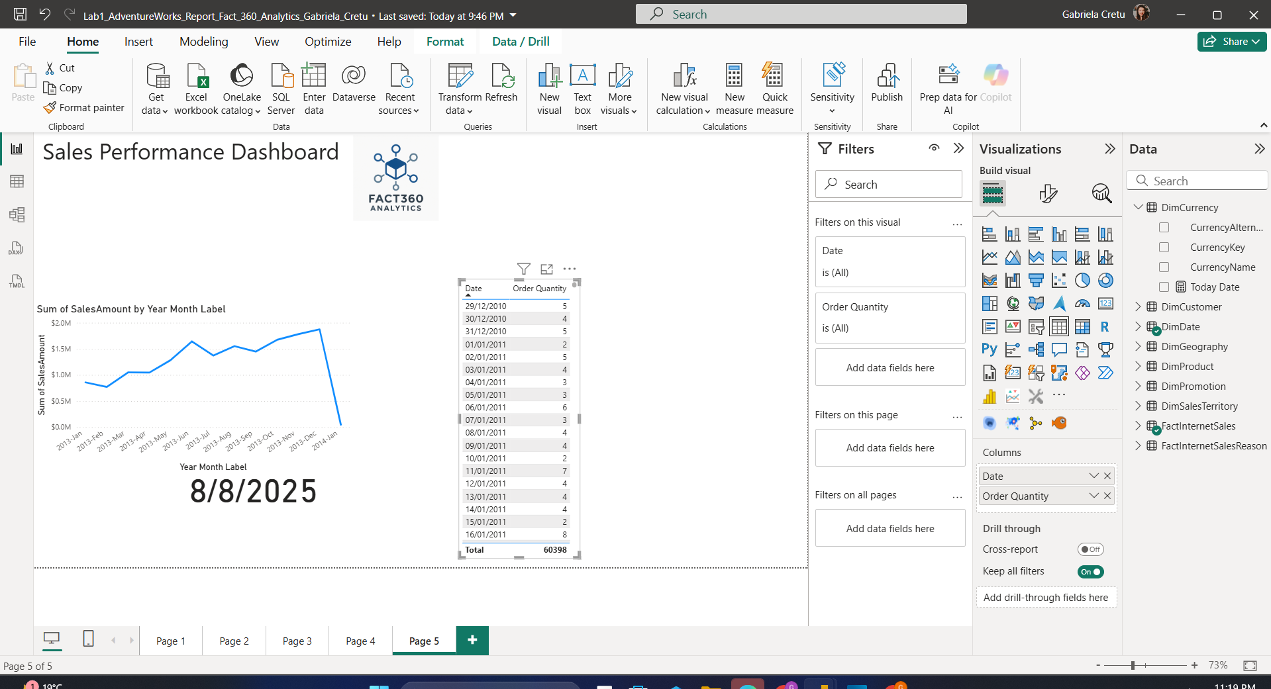

Next, before defining the cumulative order quantity using the **CALCULATE** and **DATESYTD** functions, we first ensured that the *DimDate* table was set to the Date type. Using the Table Tools, we marked it as a Date Table and set the **FullDateAlternateKey** as the primary date column. Our custom date field couldn’t be used for this purpose because it lacked the necessary constraints, although we still included it later in the report for display purposes only.

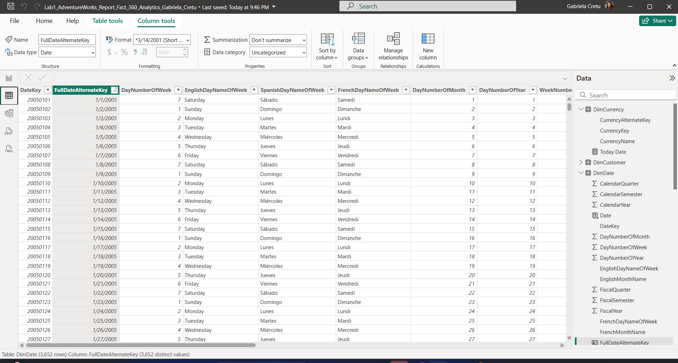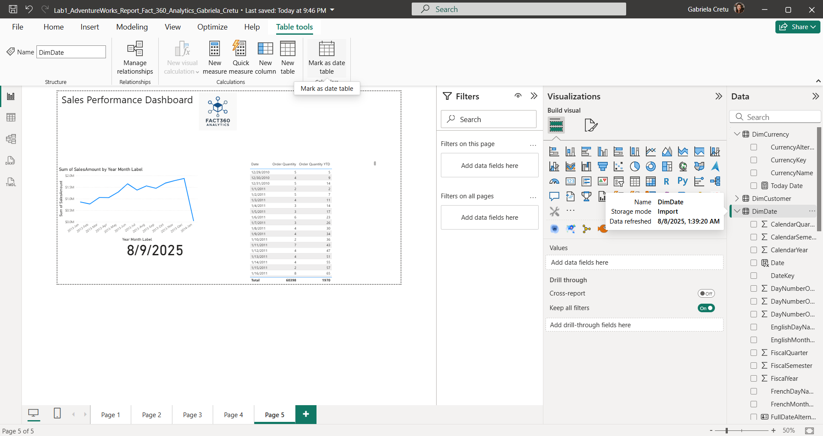

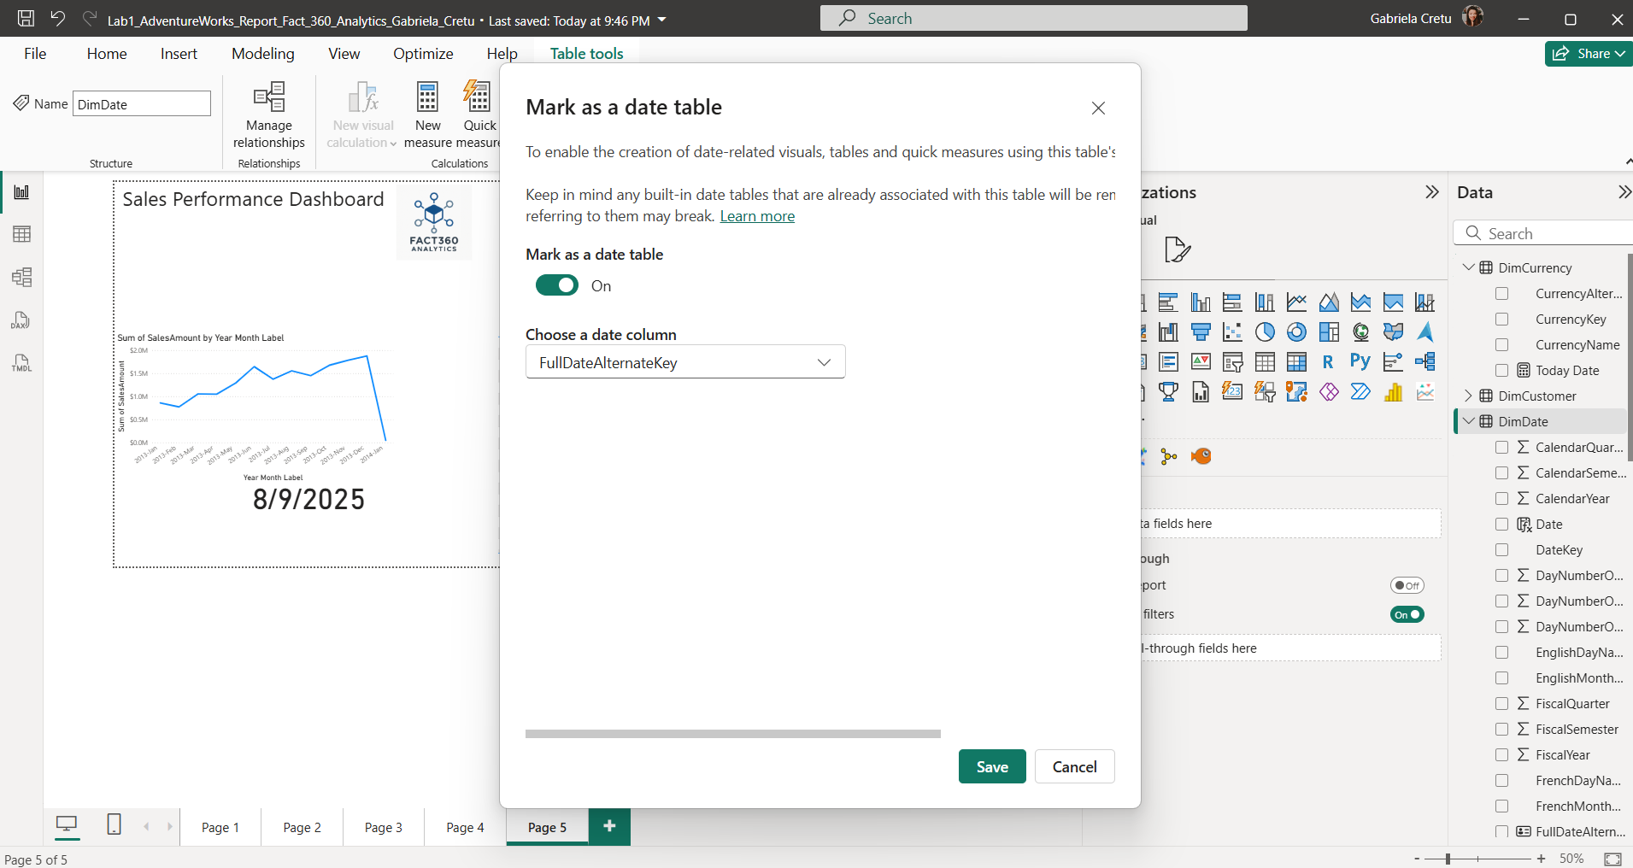

After completing this step, I was able to use all relevant DAX functions to create cumulative measures. As shown, I used the **CALCULATE** function with a **SUM** expression (which could easily be replaced by the measure we defined earlier), along with an additional filter—**DATESYTD**—that instructs the program to sum the quantities for all dates from the start of the year up to the current date.

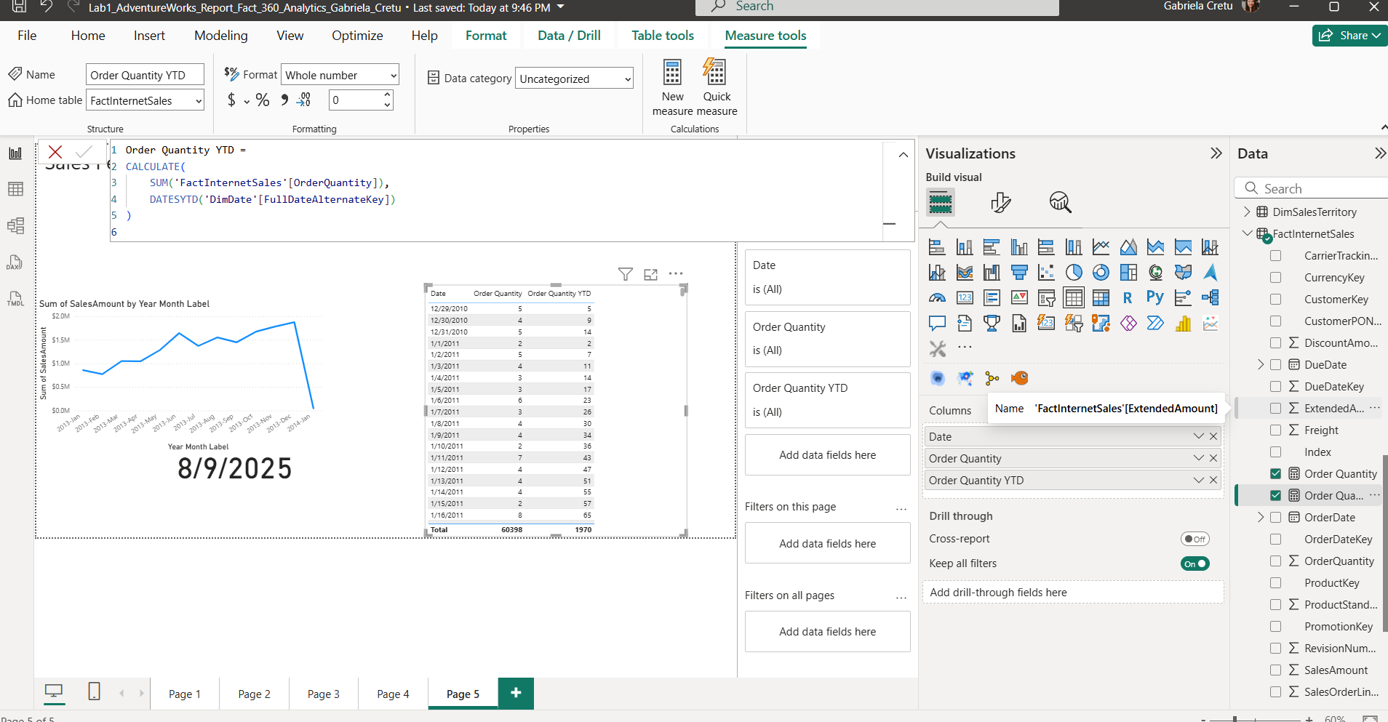

## PART B: Create lab report

**Next, we created a cumulative function with a one-year lag** to compare current performance with the same period in the previous year.  
 We achieved this by applying the SAMEPERIODLASTYEAR function to the FullDateAlternateKey column as a filter, together with the main expression inside CALCULATE — namely, the [Order Quantity YTD] measure we had already defined.

This approach works similarly to our original year-to-date calculation, but instead of showing the current period, it displays the cumulative order quantity for the equivalent time period in the prior year.From the resulting graph, we can observe that different periods show significant variations. For example:

* Between **2011 and 2012**, there was a slight increase in cumulative order quantity.
* The following year showed a substantial spike compared to the previous year.
* This was then followed by a notable downturn in the next period.

These fluctuations could be driven by various business factors, which would warrant further investigation.

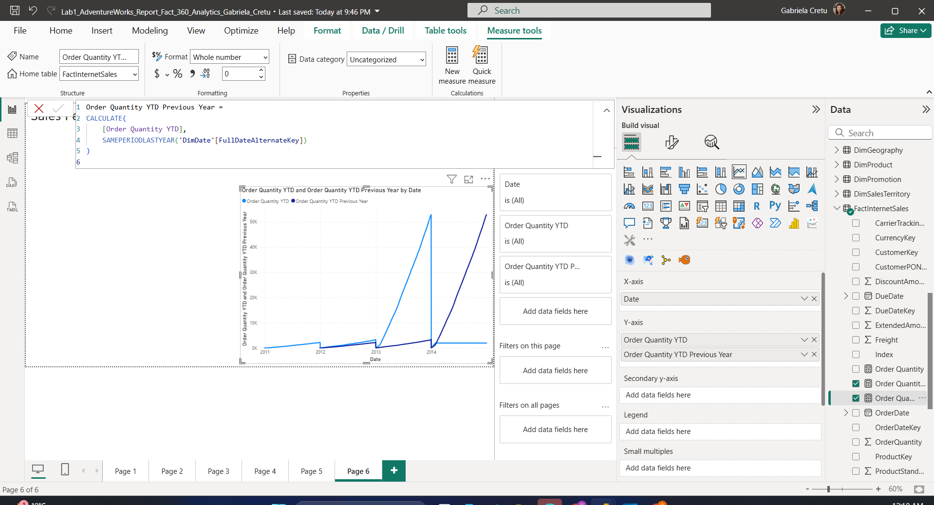

**Similarly, we constructed cumulative functions for Sales Amount** — one for the current period and one with a one-year lag. To our surprise, these two measures followed patterns very similar to the cumulative order quantity results. Specifically:

* In the first two years, sales showed only slight differences.
* In the third year, sales increased noticeably compared to the second year.
* In the final year, sales fell back to levels closer to earlier periods.

These trends suggest that both sales amount and order quantity were influenced by similar underlying factors during these years, which may point to broader market or operational shifts.

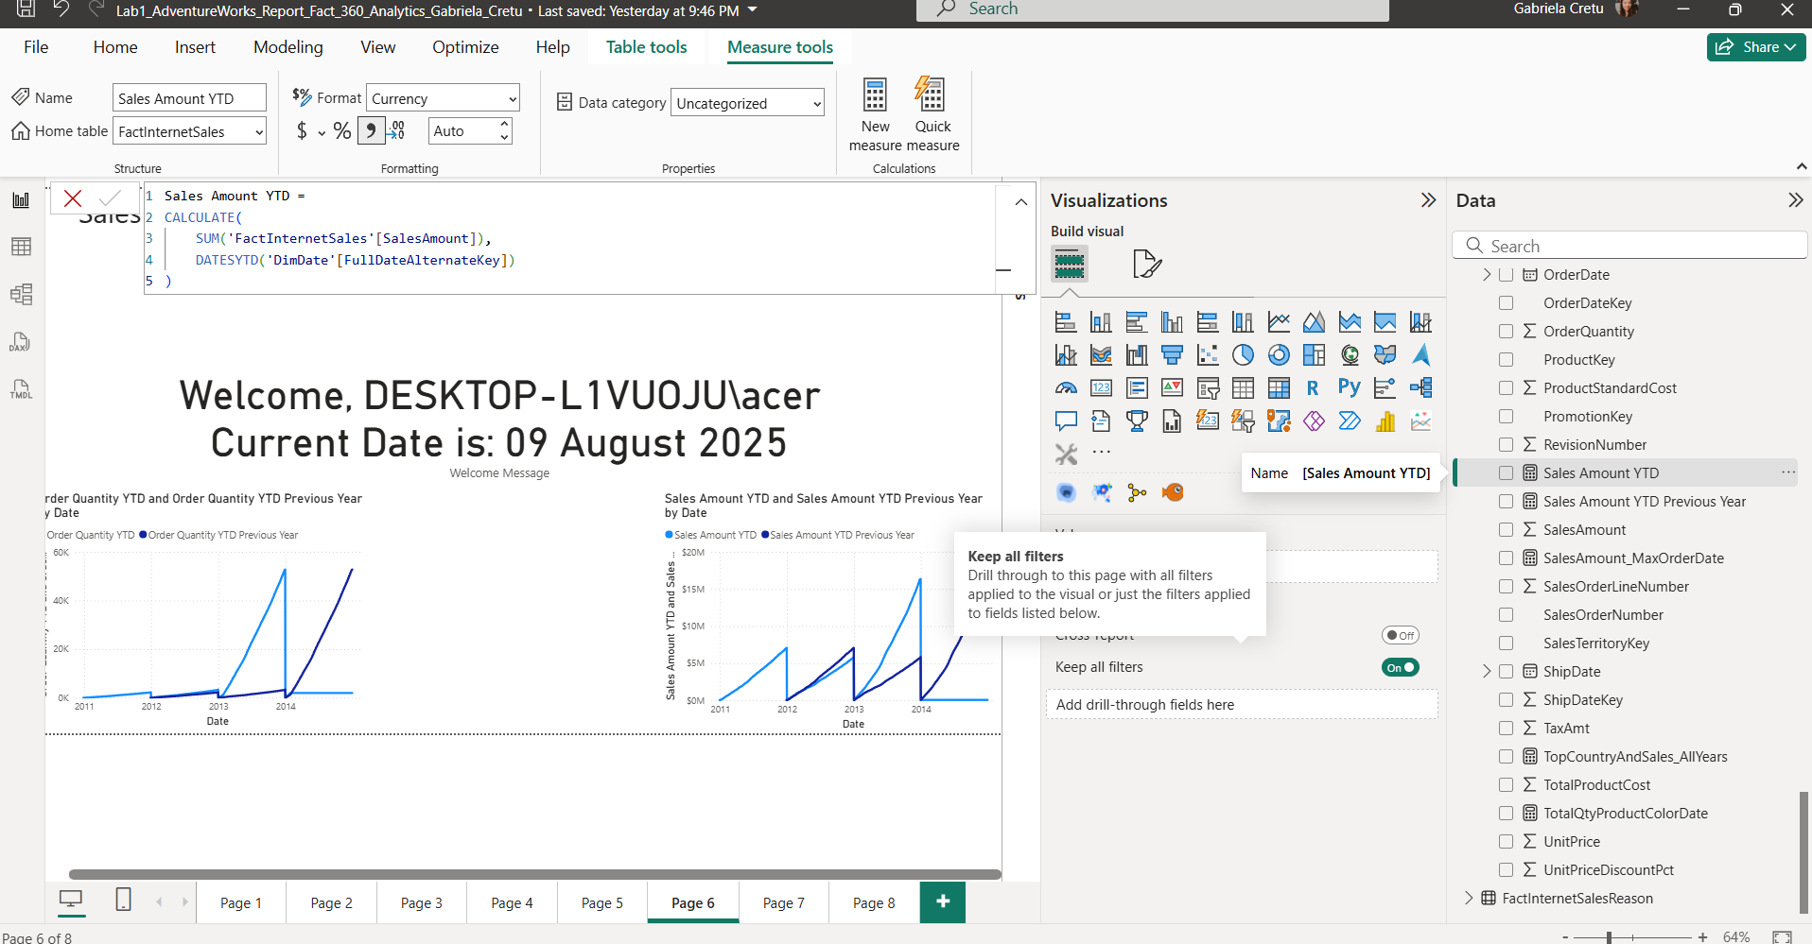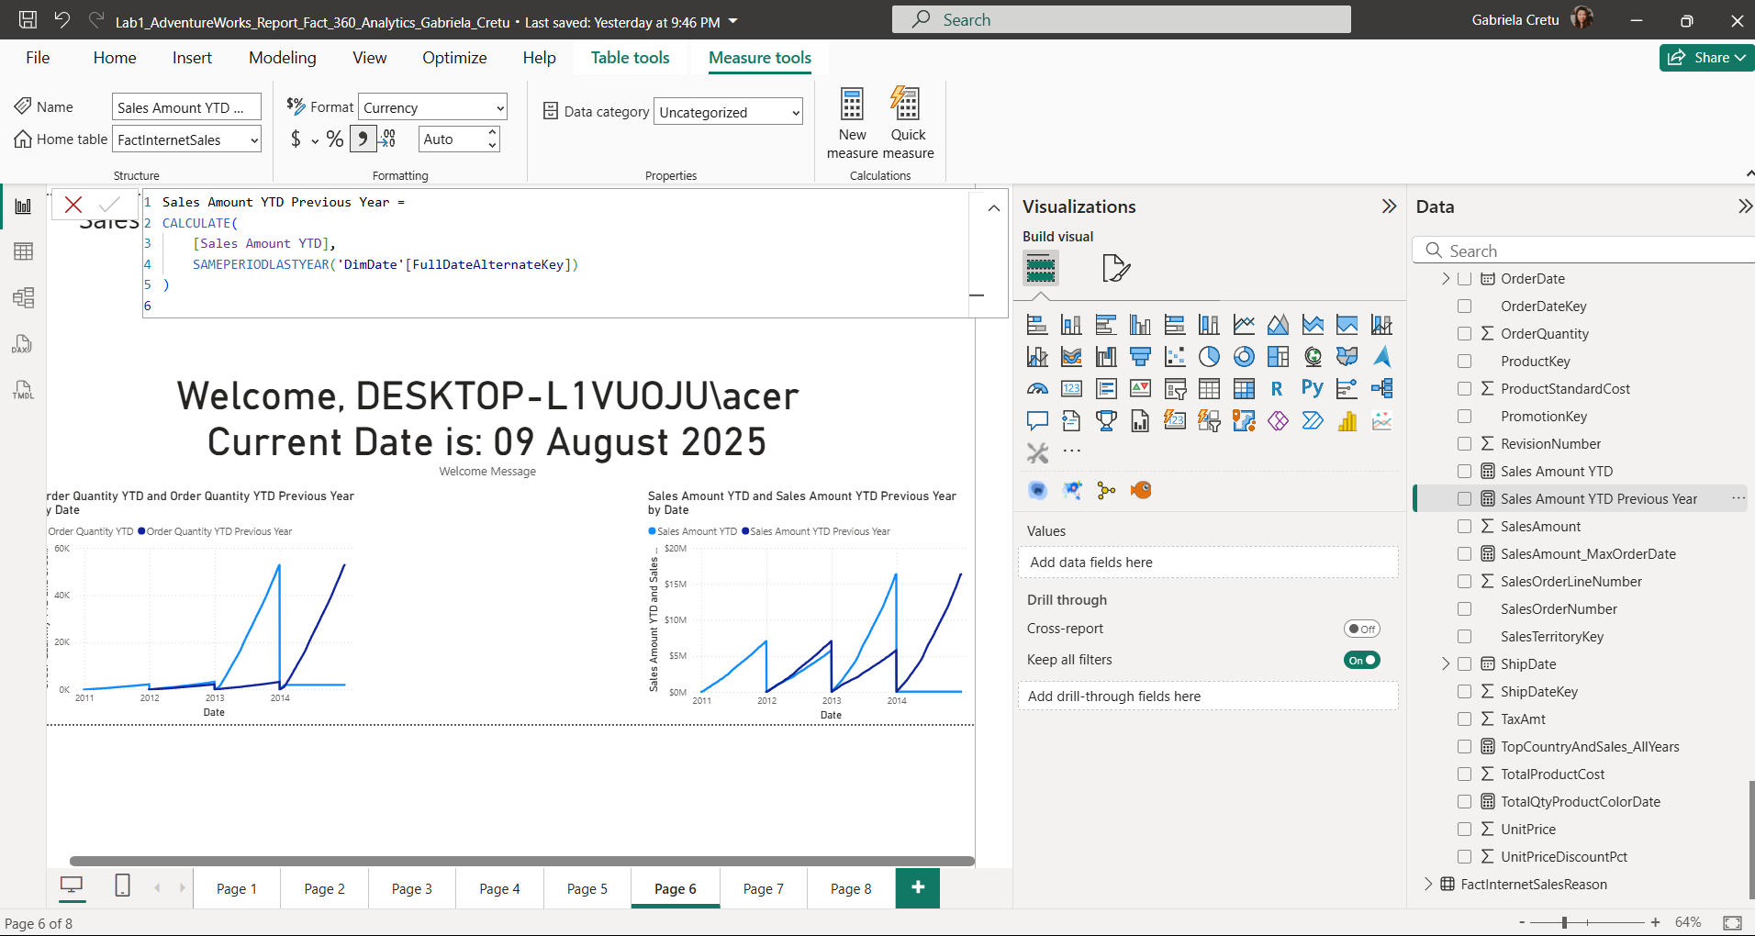

**Next, we defined a new DAX measure** that, instead of manipulating business data, produces a dynamic message for the user. This measure uses the USERNAME() function to display the current user’s login name, and the TODAY() function to show the current date.

The result is a simple, live **“Welcome”** message that personalizes the report each time it is viewed, providing a quick example of how DAX can be used beyond analytical calculations for interactive or user-friendly report features.

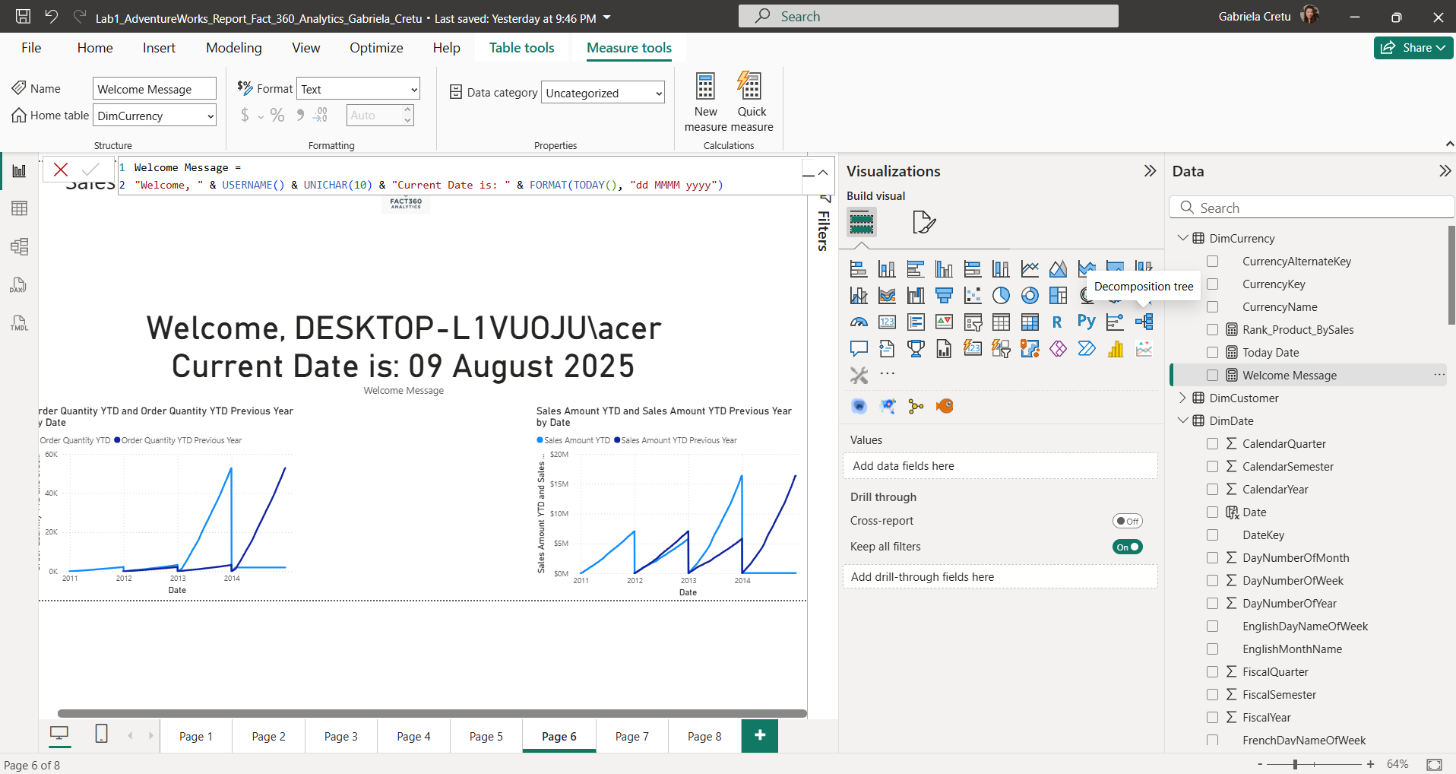

**Our next objective was to calculate the percentage contribution of products without applying any year-based filtering.**  In other words, for each **product–color** pair, we wanted to measure what share of the **total quantity sold for that pair** was contributed by each year.

This is conceptually similar to performing aggregations over partitions in PostgreSQL, where for each partition you first compute the same total in a separate column, and then use it to calculate percentages.

To achieve this in DAX:

1. We started from our existing measure for **Order Quantity**.
2. We defined a new measure for **Total Quantity per Product–Color pair over the entire period** using ALLEXCEPT. This function removed all filters except those on the product and color columns, allowing us to get the overall total for that specific combination.
3. Finally, we defined the **percentage contribution** measure by dividing the quantity for the current year by the total quantity over time for the same product–color pair.

The result shows, for each year, what percentage of the total lifetime sales for a specific product–color combination that year represents.

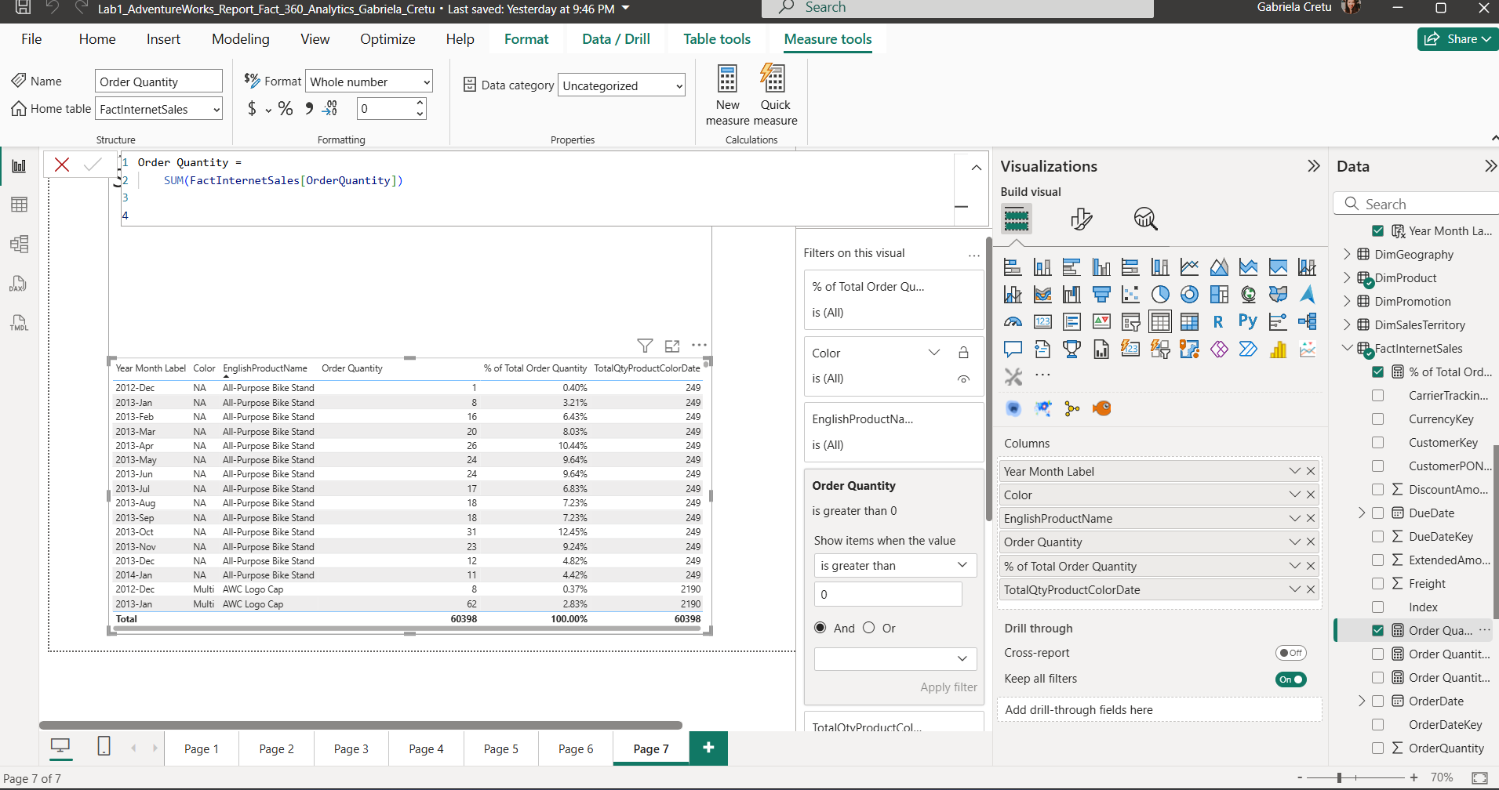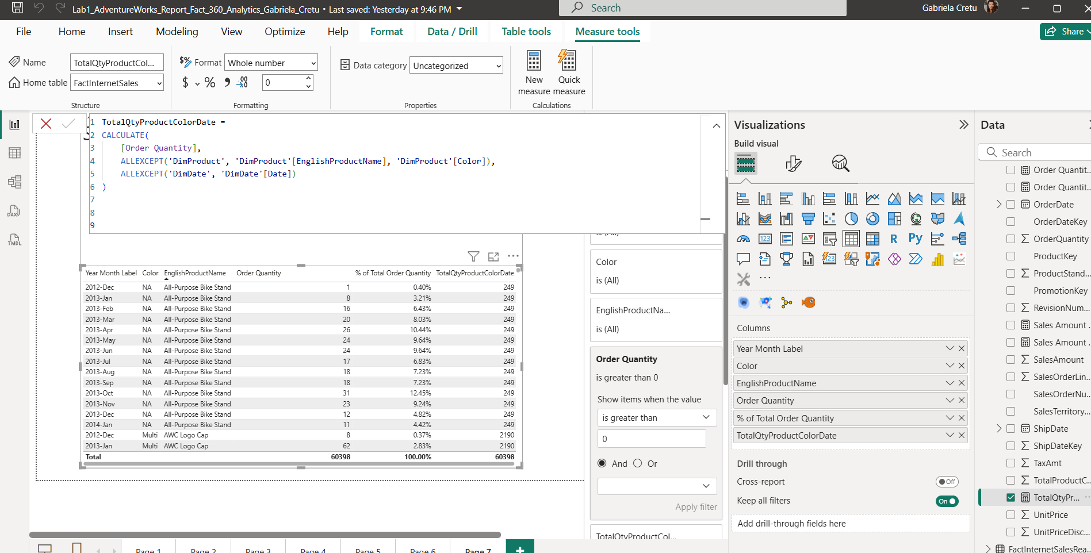

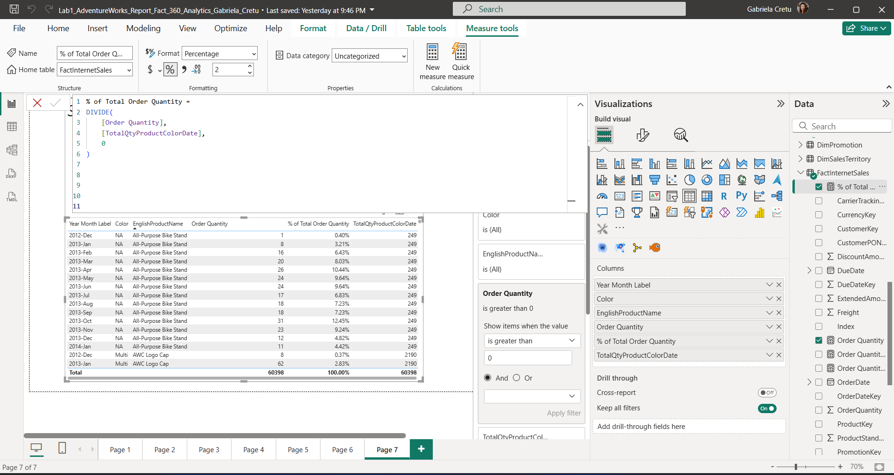

**Next, we created two measures related to the maximum order date.** The first measure computed the **Sales Amount on the latest available order date**. To do this, we:

1. Found the maximum OrderDateKey in the fact table using the MAX function, while applying ALL to remove filters from the entire fact table.
2. Used LOOKUPVALUE to translate this date key into a proper date format from the DimDate table.
3. Returned the total sales amount for that specific day using CALCULATE.

The second measure simply returned the date itself (from the LOOKUPVALUE step), allowing it to be displayed independently.

While these two calculations could be combined into a single measure, in this case we kept them separate for clarity. We then used two **Card visuals** — one to display the sales amount for the max date, and another to display the date — and grouped them together using the **CTRL + click** selection in Power BI, as shown in the report.

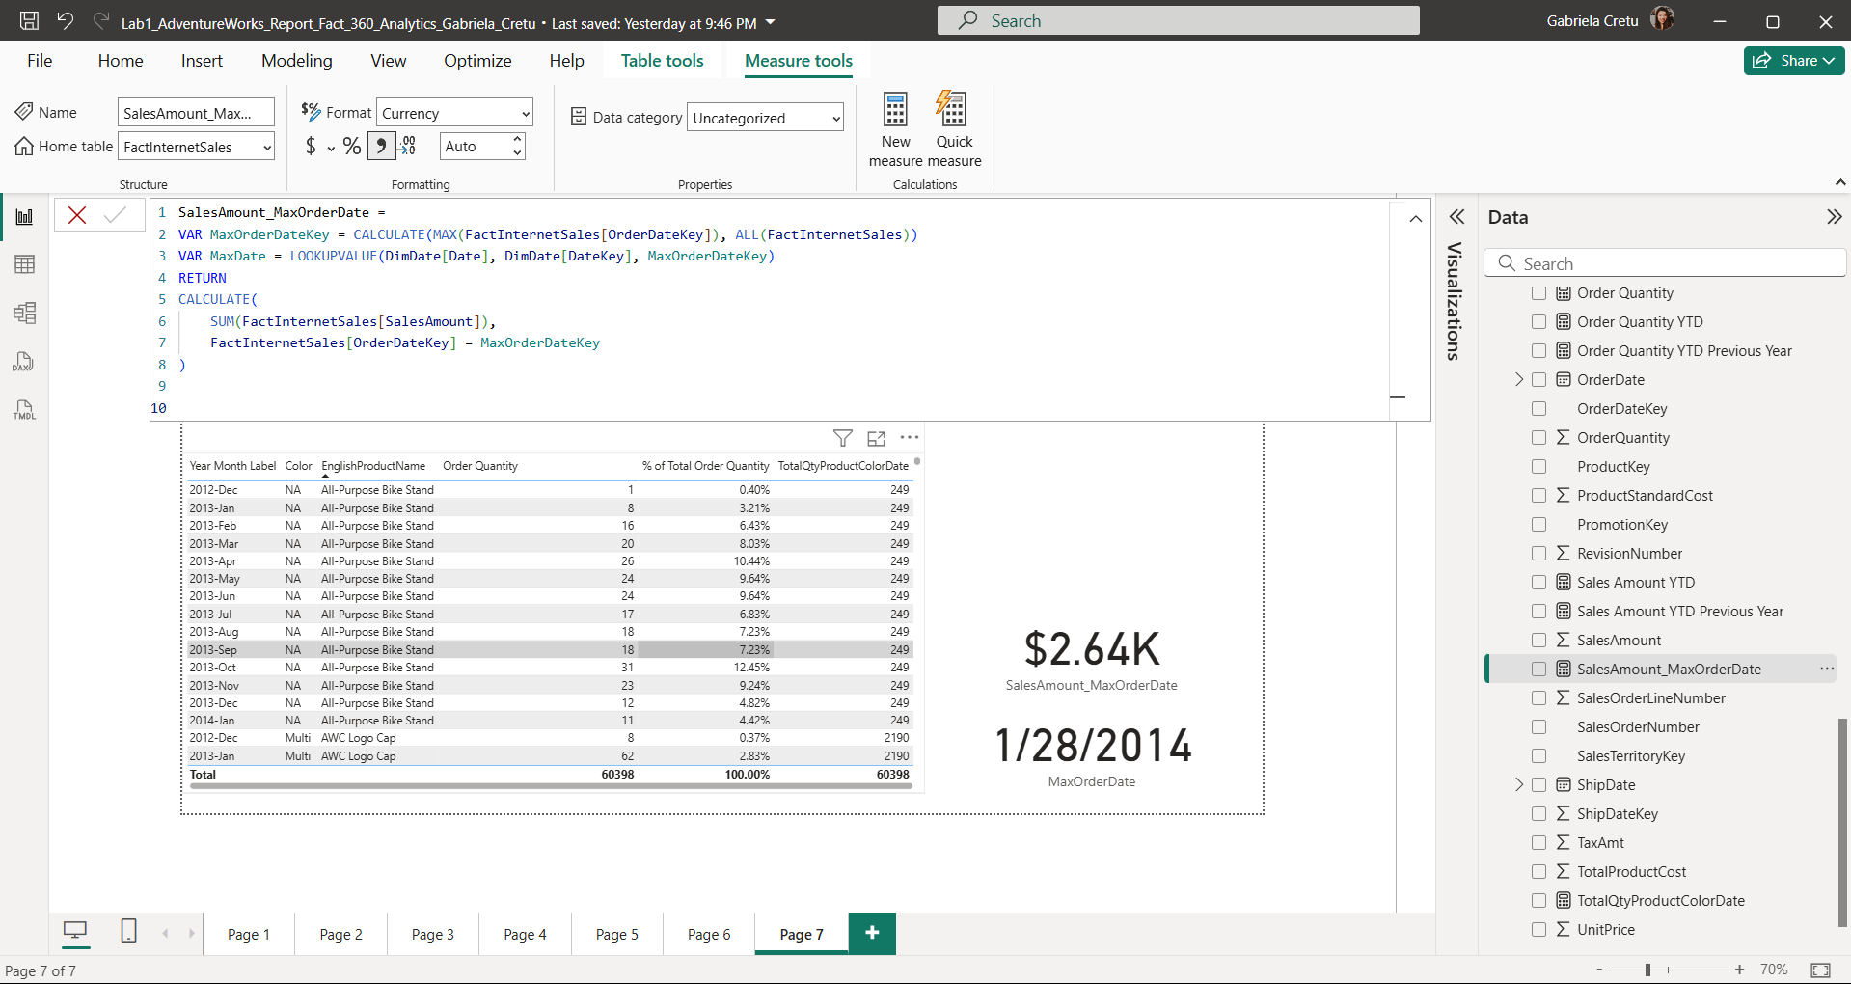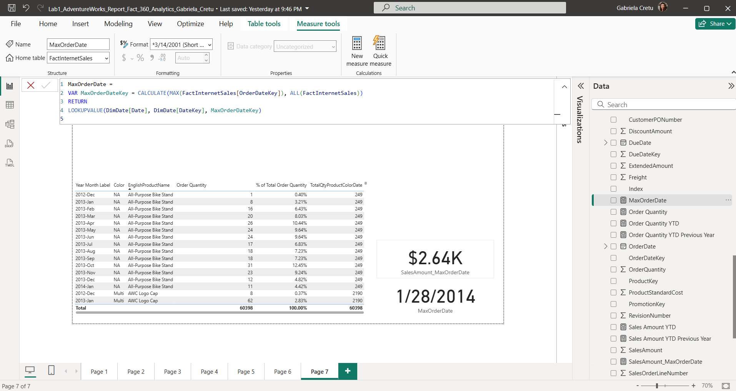

**Now, we move on to identifying and displaying the country with the highest sales amount, along with the total sales value.** This time, we created a single measure that:

1. Uses the SUMMARIZE function to group sales data by country and compute total sales per country across the entire time period.
2. Applies MAXX to find the highest sales amount among all countries.
3. Then, to find the top country, we filter the summarized table to include only the country or countries matching this maximum sales value.
4. If multiple countries tie for the highest sales, we use MAX on the country name to arbitrarily pick one.
5. Finally, the measure returns the name of the top country and its corresponding maximum sales amount, formatted in that country’s currency.

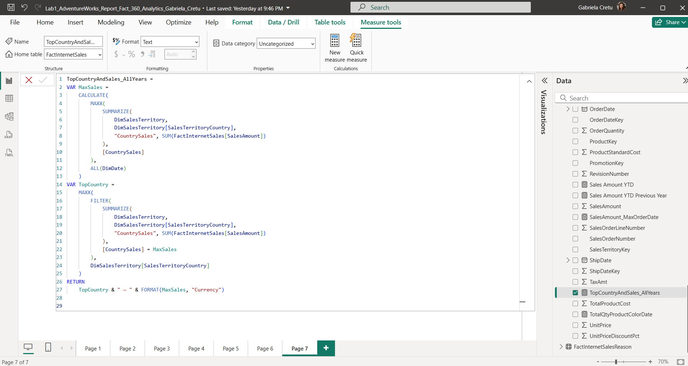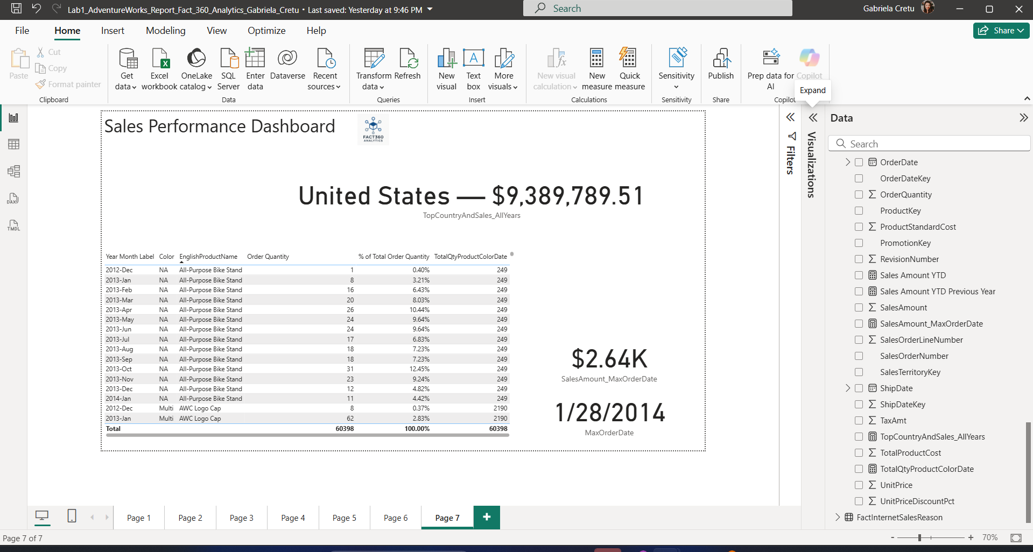

**Finally, we used the RANKX function to rank products based on their total sales amount in descending order.** We applied the RANKX function with the Skip ranking method to mimic the behavior of the RANK() window function in PostgreSQL, which skips ranking numbers when there are ties.

From the ranking, we can observe that the product **Mountain_200** generated the highest revenue among all products.

